Creating and Installing COM+ Events

Creating a COM+ Event

- To Create and install a COM+ Event first create a new ActiveX Library.
- Next create a COM+ Event object.
- Add to the COM+ Event Object interface the methods along with parameters that will be passed to the subscriber.
- Save the project and compile it.

NOTE: Do not implement the methods for the generated object.

Installing a COM+ Event

- Create a new COM+ Application in Component Services. You get to Component Services by going to Start, Settings, Control Panel, Administrative Tools, Component Services.
- To create the application, in the tree view on the left go to Computers, My Computer, COM+ Applications.

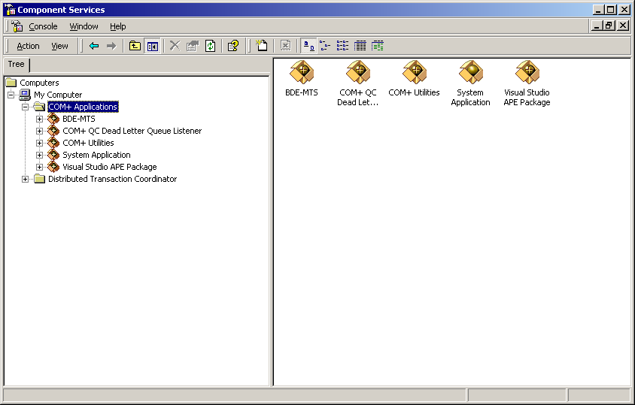

- Right click on COM+ Applications choose New, Application. Click Next, and Create an empty application.

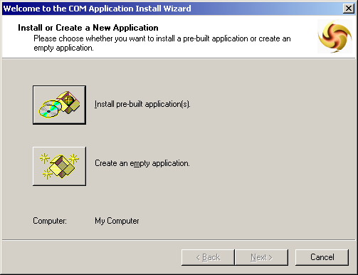

- Give the application a name. I suggest using all the defaults.

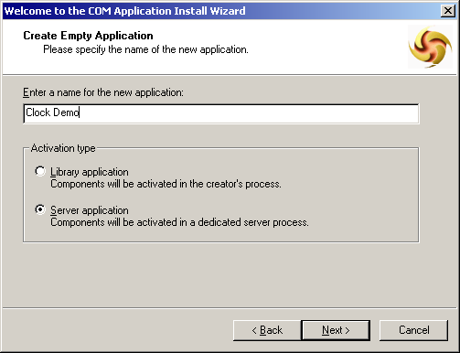

- Now that you have the COM+ application created add the event. Expand the application and select Components. Right click on Components and choose New, Component.

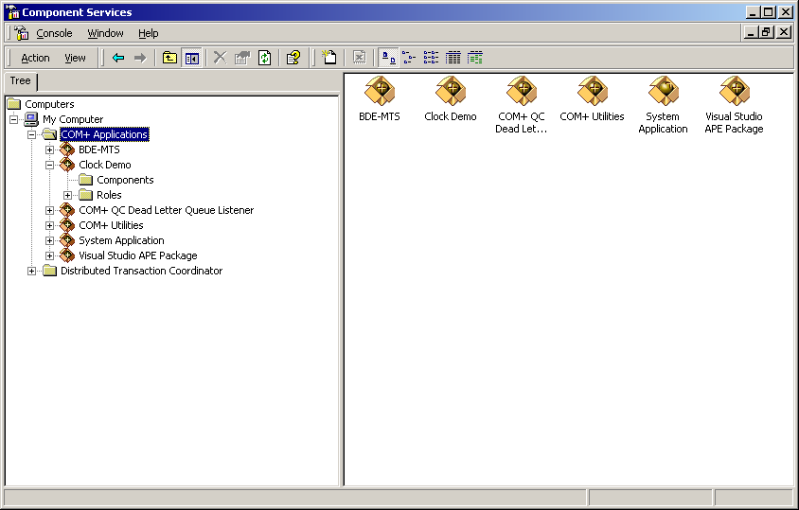

- Click Next and Choose Install new event class(es). Browse for the DLL that contains your COM+ Event Object and click Next and Finish.

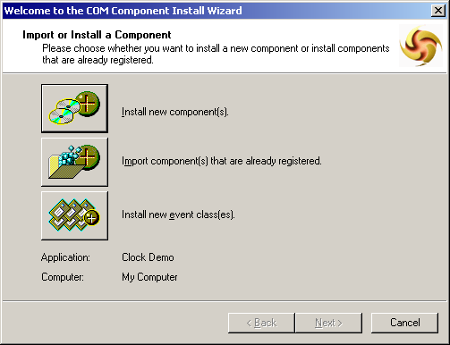

- The COM+ Event Object will now be visible in the Component Services.

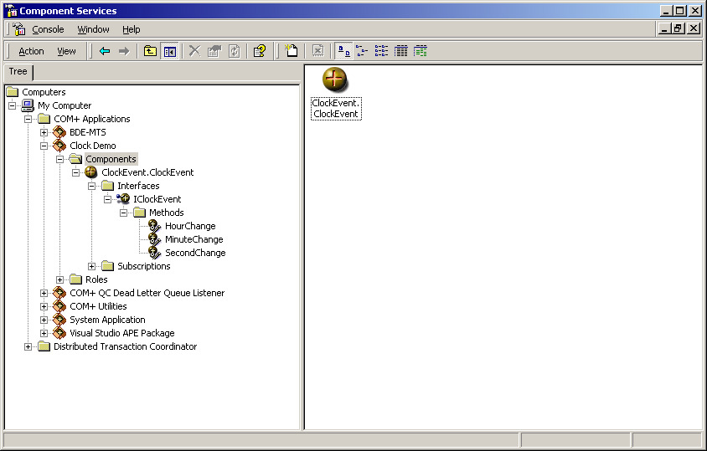

Creating and Installing COM+ Subscriptions

Creating a COM+ Subscription

- To Create a COM+ Subscription, create a new ActiveX Library.
- Next create a COM+ Subscription Object and browse for the interface created for the COM+ Event.
- Implement the generated methods that this object will subscribe to.
- Save the project and compile it.

Subscribing to a COM+ Event

- Expand the application and select Components. Right click on Components and choose New, Component.
- Click Next and Choose Install new component(s).

- Browse for the DLL that contains your COM Subscription Object and click Next and Finish.

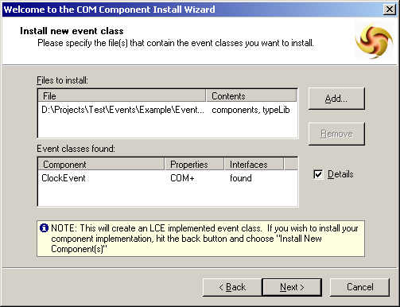

- Click on Subscriptions under the COM Subscription Object and right click and choose New, Subscription.

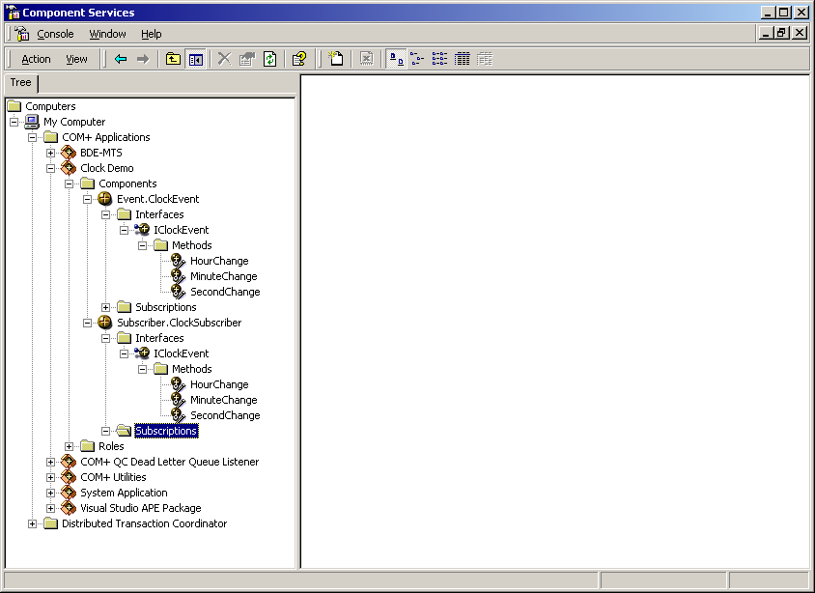

- All COM+ Events will be shown in the dialog, choose the methods or entire object you want to subscribe to and click Next.

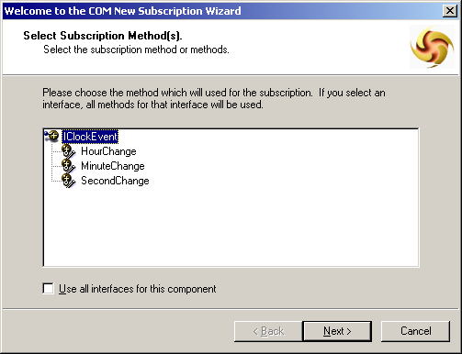

- Now choose the COM+ Event object you are going to subscribe to and click Next.

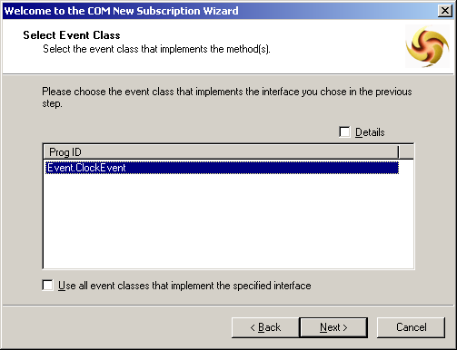

- Enter a Subscription name, click Enable this subscription immediately, and click Next.

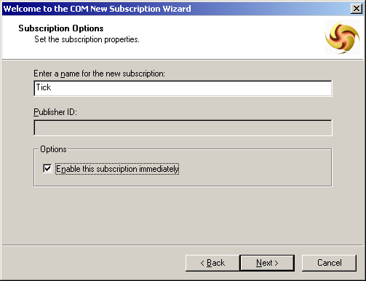

- The COM+ Subscription will now be visible in the Component Services.

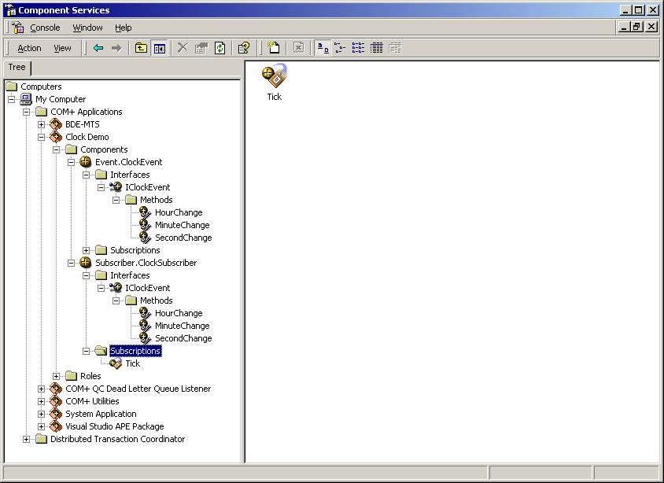

Creating COM+ Publishers

- To trigger the COM+ Event, in your application Choose Project, Import Type Library.
- Add the added file to your uses clause or includes.
- Create an instance of the COM+ Event Object’s interface and assign the object created by the constructor of the Co class to it, and to trigger the event call the method. COM+ will look up the subscriptions for you. So for example in C++ and Delphi:

void __fastcall TForm1::Button1Click(TObject *Sender)
{
TCOMIClockEvent Event;
Event = CoClockEvent::Create();

// Now call the COM+ event object as you normally
// would: Event.SomeMethod()
}

procedure Tform1.Button1Click(Sender: TObject);
var
Event: IClockEvent;
Hour, Minute, Second: Integer;
begin
Event := CoClockEvent.Create;

// Now call the COM+ event object as you normally
// would: Event.SomeMethod
end;

